***Genisis Plus***

**PROJECT CHARTER**

**Date:**

**Version: 1.0**

**Prepared by: Rick Seiden**

**PROJECT CHARTER**

|  |  |
| --- | --- |
| **Project Name** | Genesis Plus |
| **Project Sponsor(s)** | Harish Ramani, ​Balaji Srinivasan |
| **Proposed Start Date** | October 2023 |
| **Proposed End Date** | May 2023 |

1. **Project Background and Rationale**

This project is the next phase of Project Genisis Phase 1. This phase, Genisis Plus, will enable end-users to obtain reports using a self-service model. Genisis Plus will implement Snowflake to enable end-use self-service and sunset Oracle EDW. This project will have two tracks:

* Data Domain Track – Build new data pipelines from all HoT internal and external sources into Snowflake​
* Consumption Models & Self-Service – Define HoT Level measures, metrics, business definitions, KPI’s and implement in Snowflake for self-service consumption

1. **Project Goal**

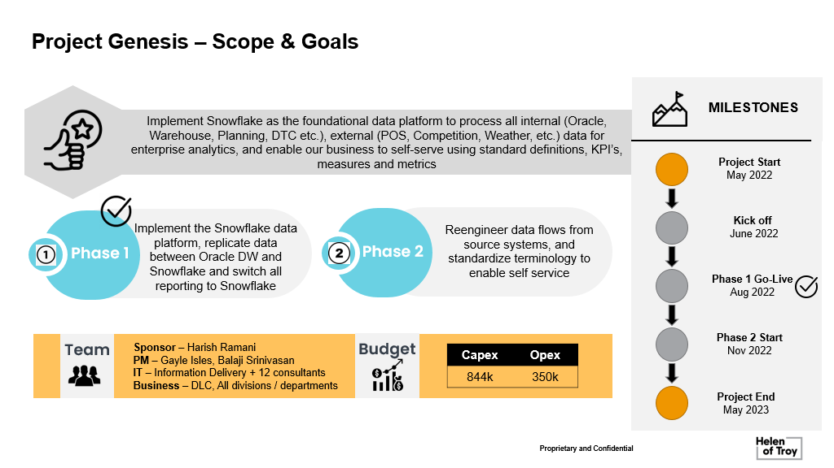

1. **Deliverables**

* Requirements & Design​
* Reengineer Data ingestion​
* Build & Unit Test Data Pipeline​
* Orchestrate Data Jobs​
* User Acceptance Testing​
* Documentation & Deployment

1. **Scope**

* Master Data
* Order to Cash
* Logistics
* Procure to Pay
* Finance
* Hypercare

1. **Success Criteria / Expected Business Benefits**

|  |  |
| --- | --- |
| Current Case | Future Case |
| **Standard KPI’s, Definitions, & Measures** | |
| Divisional definitions, hierarchies, KPI’s that don’t align across HoT | Genesis Plus to establish and align Divisional definitions, hierarchies, KPI’s |
| ~150 people within the business performing silo analytics at different parts of business | Enterprise analytic standards in place |
| Business does not trust the data due to different terminologies and definitions | Standard and agreed-upon terms and definitions established |
| Prioritize HoT level metrics ex: for margins, working capital, turns, etc and drive consistent actions | As part of Genisis Plus, a ranking will be established |
| **Business Self-Service** | |
| 3 people in IT build reports and dashboards for all of the business | A robust, self-serve model in place |
| Standards, definitions, KPIs and governance for data not established | Standards, definitions, KPIs and governance for data established |
| Current BI Platform not usable/intuitive for business self-service and adoption is difficult | Training and other methods in place to drive platform adoption |
| Best in class data consumption tool not in place | Best in class data consumption tool deployed |
| **Drill down capability to drive actions** | |
| Current reports are either too high-level or too detailed | Genesis Plus with enable users to target the data they need using a self-service model |
| Lack of standard hierarchy impacts ability to drill down highest to lowest level | Genesis Plus will allow users to select the level of detail they desire |
| **Data Trust and Data Quality** | |
| Business does not trust the data due to lack of transparency in how / when data is processed | ?? |
| Lack of trust also due poor data quality driven by multiple definitions, hierarchies, terms across brands and divisions | Genesis Plus will vastly improve data quality across brands and divisions |
| Business and IT spend significant time in verifying data quality rather than using the data for decision making | This project will significantly reduce or even eliminate IT verifying data quality |
| **Platform Reliability and Scalability** | |
| Lack of QA environment in current platform leads to high rate of production defects | ?? |
| Lack of Disaster Recovery capability, these are available out of box in Snowflake | Genesis Plus will address Disaster Recovery |
| Instances of delayed reporting, and response time to load reports in current platform | Near Real-time data and report creation to be in place |
| Ability to instant clone helps improve budget & forecast load accuracy, and validation | Genesis Plus will improve instant clone helps improve budget & forecast load accuracy, and validation |

1. **Proposed Timeline & Key Milestones**

1. **Resources & Organization**

|  |  |  |
| --- | --- | --- |
| **What** | **Who** | **Role / Comments** |
| Project Sponsor(s) | Harish Ramani, ​Balaji Srinivasan |  |
| Steering Committee | Tracy Scheuerman, Aloke Mishra, Marisol Ayala, Matt Dunn, H&W - TBD, Craig Antolik, Harish Ramani, Anil Johnson, Balaji Srinivasan​ |  |
| Project Managers (Business/IT | Rick Seiden | PM/Scrum Master |
| Team Members | Sai Pedditi, Venkat M, Mel Blizzard, Derek Spear, Aditya Gondesi, Gurpreet Singh, Pradhnya Shahu, Shivaram Kolla, Srinivas Maram, Lakshmi Narayana, Neha Jain | Develop Team |
| Other | Sai Pedditi, | Project Leader |

1. **Assumptions**

**Balaji, please add**

1. **Risks**

|  |  |  |
| --- | --- | --- |
| **Risk** | **H,M,L** | **Mitigation** |
| Dependency on external resources​ | M | Interview each resource and use of multiple agencies​ |
| Budget needs in FY24​ | M | Completion dependent on appropriate budget allocations in FY24 |

1. **Budget**

*.*

**Balaji, please add**

1. **Reporting**

*Provide an overview of key reporting processes / meetings – perhaps using the table below.*

*A more detailed communications plan can be worked up in the Project Plan if needed.*

|  |  |  |  |  |
| --- | --- | --- | --- | --- |
|  | **What** | **Audience** | **Frequency** | **Responsible** |
| **Meetings** | Steering Committee Meetings | Steer Co, PM, PMO | Monthly | PM |
| Key Stakeholders | Key Stakeholders | Monthly | PM |
| **Reports** | Status Reports | Using Jira | On-going | PM |

1. **Authorizations**

|  |  |  |  |
| --- | --- | --- | --- |
|  | **Name** | **Signature** | **Date** |
| **Approved By** |  |  |  |
|  |  |  |